2016 EYH Professional Development for Adults
Adult Registration closes on October 1, 2106

8:00 am to 8:45 am: Complete registration at LRC Lobby

8:45 am to 9:30 am: Attend “Welcome” and 20th EYH Keynote by Dr. Rhea Seddon

9:30 am to 11:30 am: Best Practices for Girls in STEM

11:30 am to 12:30 pm: Networking lunch

12:30 pm to 2:30 pm: Role Models Matter (have a document to link to this session)

2:30 pm to 2:45 pm: Evaluation and closing

Registration:

Parents, teachers, informal STEM educators, guidance counselors, Girl Scout leaders and other adults who encourage and support girls in STEM are invited to participate. All participants must complete the MTSU Agreement Regarding Participation in an Event and mail to:

MTSU EYH
Attn. Dr. Judith Iriarte-Gross
1301 East Main Street
P. O. Box X161
Murfreesboro, TN 37132

You can also scan and email the participation form to: eyh@mtsu.edu

The cost for this session is $25.00 and includes lunch.
If you wish to purchase an EYH t-shirt, the cost is $10.00.
An EYH T-shirt must be ordered in writing by September 15, 2016.
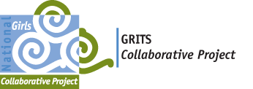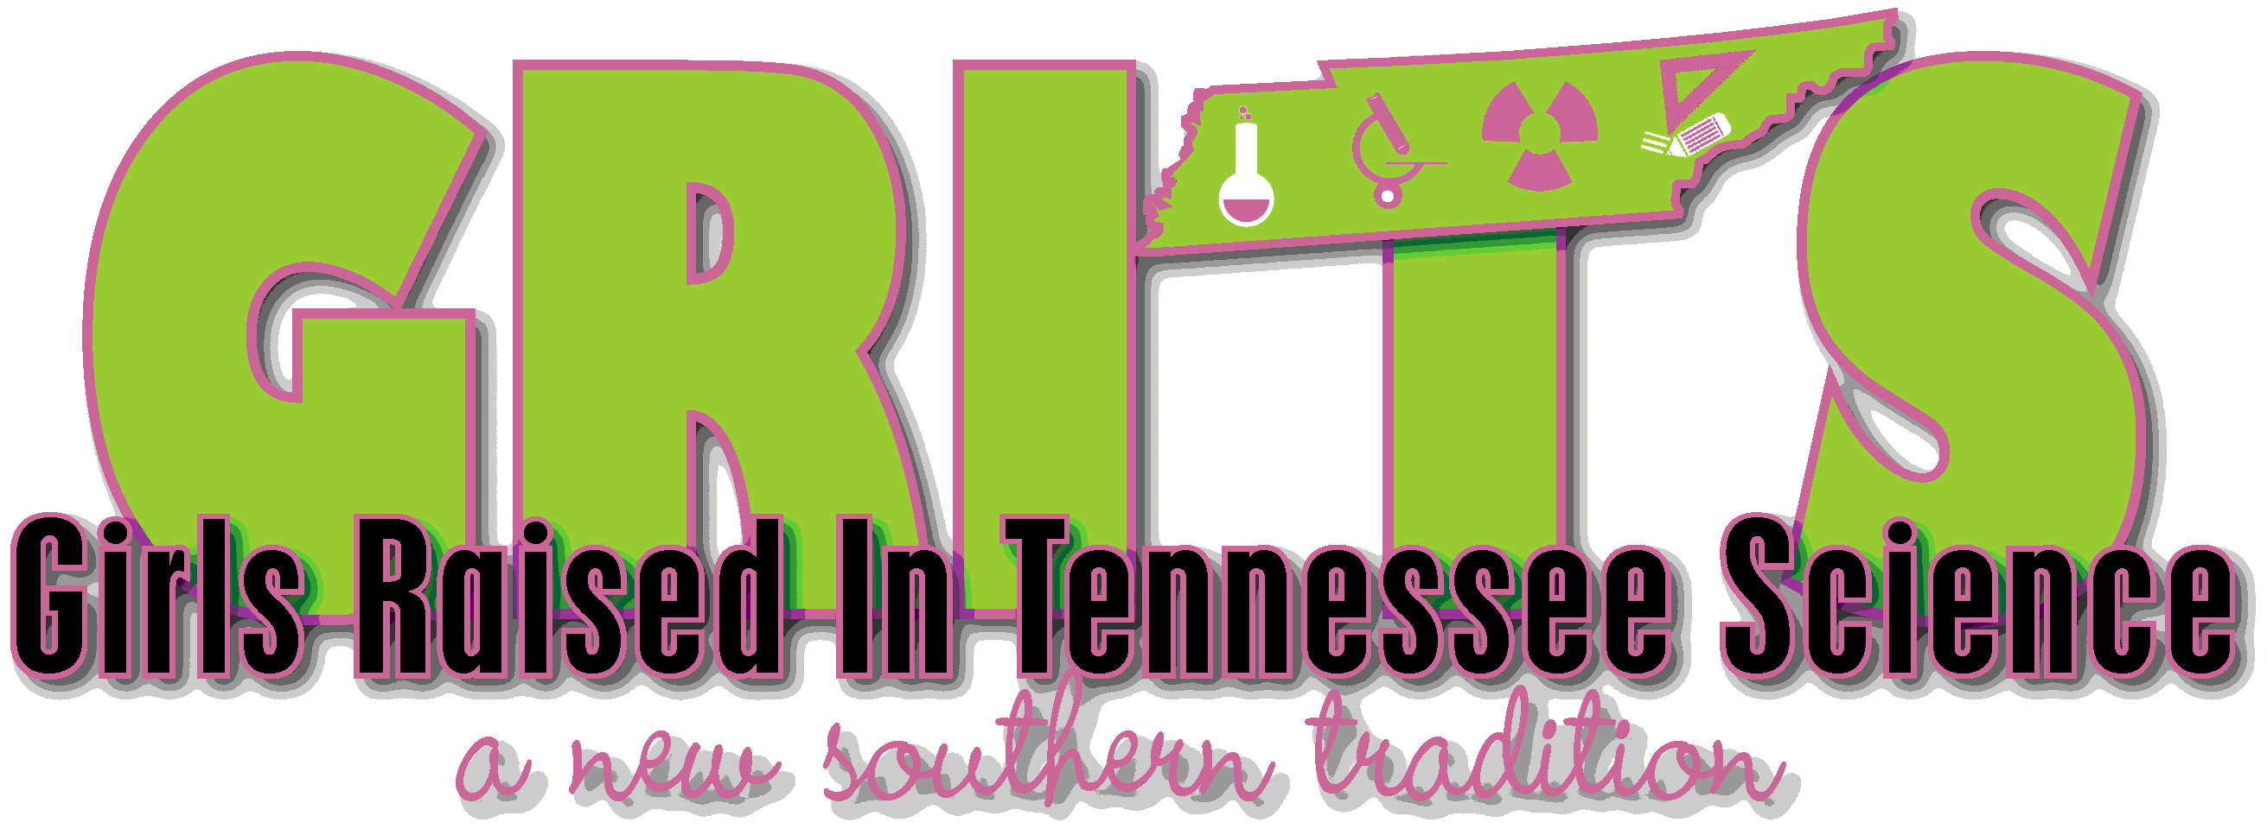

Best Practices for Girls in STEM

In this session, participants will learn about the Girls Raised In Tennessee Science (GRITS) Collaborative Project, the Tennessee collaborative of the National Girls Collaborative Project, NGCP. GRITS is based in the Women In STEM (WISTEM) Center on the MTSU campus.
Collaboration is important because:
- Collectively utilizes Tennessee’s STEM resources
- Builds a stronger STEM community
- Serves all 95 counties in Tennessee
- Develops the future Tennessee STEM workforce
High levels of collaboration among educators, parents, and programs which engage girls in STEM increases the efficiency, effectiveness and overall capacity of programs and therefore increases opportunities and improves experiences for girls in STEM.

During this morning session, participants will:
- Meet others via speed networking
- Learn about GRITS and the WISTEM Center
- Discover Tennessee STEM Resources in the Connectory
- Ask questions and share stories about how collaboration benefits girls-serving STEM programs

