**October Newsletter**

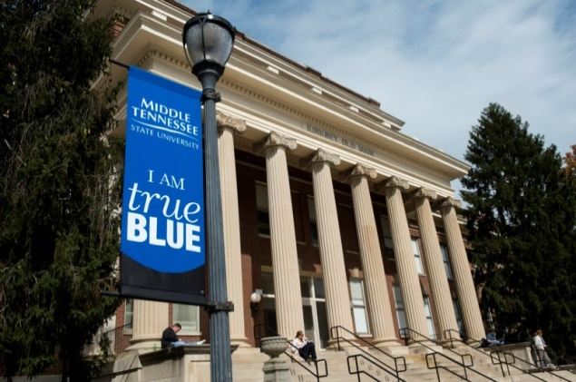

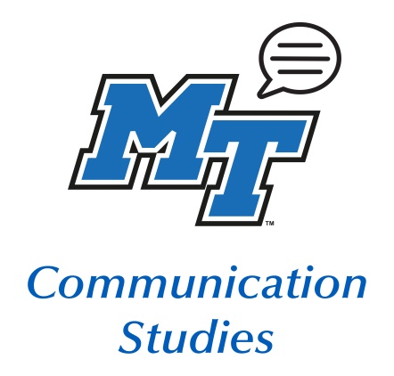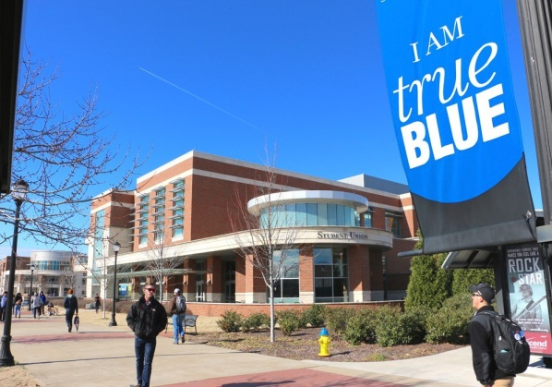

**October Dates:**

* 10.02 – 10.03 Speech & Debate Tournament
* 10.05 Last day for voter registration
* 10.05 Meditation Workshop
* 10.07 Free Flu Shots
* 10.12 Meditation Workshop
* 10.13 – 10.15 Speech & Debate Tournament
* 10.13 Research Workshop: Library Research and Literature Review
* 10.14 Early voting begins

**November Dates:**

* 11.03 Election Day
* 11.10 URC Open House
* 11.13 – 11.15 Speech & Debate Tournament
* 11.19 – 11.22 NCA Conference



* 10.15 Research Workshop: Completing the Research Proposal
* 10.19 Meditation Workshop
* 10.21 A Conversation about Racism conference via Zoom
* 10.26 Meditation Workshop
* 10.29 Early voting ends

Meet Dr. Ronald Kates

**Who am I?**

Serving as the Interim Chair for the Communication Studies department, Dr. Ronald Kates obtained his PhD from Georgia State University in 1997. Aside from serving as the chair person, he can be found teaching courses in English, sports literature, and renaissance literature. Through his hard work and dedication, he became a recipient for one of the MTSU Foundation’s Outstanding Teacher Award in 2012.

[Click here to learn more about me!](https://www.mtsu.edu/faculty/ronald-kates)

Dr. Ronald Kates *Professor & Interim Chair*



RESEARCH ASSISTANCE NEEDED

**Research Study #1**

The investigator is currently looking for interview participants for a study that examines the relationship between family communication patterns and weight stigma development.

If you would be willing to participate in a 45-60-minute interview, contact [Dr. Mary Beth Asbury](mailto:mbasbury@mtsu.edu)

**Free Flu Shots!**

Date: October 7th

For further information, contact: 615.898.2988

**Research Study #2**

The investigators are looking for male students to participate in as study to discuss their reaction to terms related to gender-based violence, their experiences with how men talk with each other about these issues, and how to improve future programming in these areas to appeal to men.

If you would be willing to participate in a 90 minutes session and an additional 10 minutes or so to take a screener survey and do payment paperwork, contact [Dr. Natalie Hoskins](mailto:Natalie.Hoskins@mtsu.edu) [or] [Dr. Rebecca Oldham](mailto:Rebecca.Oldham@mtsu.edu?subject=Engaging%20Men%20Study)

CHECK OUT THESE INTERNSHIPS!

**Development Internship**

About the Internship

The United Way of Rutherford & Cannon Counties seeks an intern to assist in activities related to events, fundraising, and donor development. The ideal candidate for this unpaid internship is a self-starter, organized, and detail-oriented with strong interpersonal skills. The candidate should be a junior or senior that is available 8-20 hours per week.

[Click here for further information!](https://www.yourlocaluw.org/?fbclid=IwAR2otg7hIq6SWqW7YhRBSQ90FKlAnLsEX9xVLFgJtUsrZmZ01eU3l895sAo)

To apply, please send your cover letter and résumé to:

[Leigh Ann Lamb](mailto:Leighann.lamb@yourlocaluw.org) [or] [Janet Martin](mailto:janet.martin@yourlocaluw.org)



A note about the Facebook group: It is not “secret” but it is private, so students will have to request to join.

**Facebook:** MTSU Comm Studies

**Instagram:** @mtcommstudies

**Twitter:** @mtcommstudies

**Linkedin:** MTSU Department of Communication Studies

**Volunteer Income Tax Assistance**

About the Internship

The United Way of Rutherford & Cannon Counties has a Volunteer Income Tax Assistance program (VITA) that is seeking unpaid interns to help coordinate the free tax help. You can work a combination of remote and in person. This internship can offer you great experience to help find your next position.

[Click here for more information!](https://www.yourlocaluw.org/VITA?fbclid=IwAR2otg7hIq6SWqW7YhRBSQ90FKlAnLsEX9xVLFgJtUsrZmZ01eU3l895sAo)

To apply, please send your cover letter and résumé to: [Debbie Curtis](mailto:Debbie.Curtis@yourlocaluw.org)

**Social Media Dev. Intern**

About the Internship

The intern will need to have a strong grasp of the different social media platforms whom will transform the company’s presence in media. The internship will be fully remote with a flexible schedule and opportunity to gain college credit afterwards.

[Click here to check out the website!](https://www.notsosilent.com/)

**This is a **PAID** internship**

[Click here to apply!](https://www.indeed.com/viewjob?jk=14a597d930a5f308&from=serp&from=mobRdr&prevUrl=https%3A%2F%2Fwww.indeed.com%2Fm%2Fjobs%3Fq%3DStudent%2BIntern%26l%3DSmyrna%252C%2BTN&utm_source=%2Fm%2F&utm_medium=redir&utm_campaign=dt)

A Conversation about Racism: Connecting the Past to the Present

Keynote Speaker: Dr. Ersula Ore

*author of* [*Lynching: Violence, Rhetoric, and American Identity*](https://www.upress.state.ms.us/News/2019/Ersula-J.-Ore-on-Lynching)

About the Speaker: Professor Ore is the Lincoln Professor of Ethics in the School of Social Transformation and Associate Professor of African & African American Studies at Arizona State University. Her research agenda focuses on the suasive strategies of Black Americans and investigates the relationship between physical and discursive violence, citizenship, and race. Ore's book, Lynching: Violence, Rhetoric, & American Identity (2019), which explores American lynching as an ongoing practice of racialized citizenship connected to anti-Black policing, received the 2020 RSA Book Award from the Rhetoric Society of America.

**DATE**:

Wednesday, October 21st

**TIME**:

5-30 – 7:00 pm CST

**Location**:

Zoom

**Link**:

[Click here to join!](https://mtsu.zoom.us/j/91039076188?pwd=VDcyQytPdFh4WjJCODV0eVVORWlPUT09)

Meeting ID: 910 3907 6188

Passcode: 484209​

**Do You Need to Meet with a Group?**

Students have access to a Zoom account and can host their own meetings with a free MTSU account:

[Click here to get started!](https://zoom.mtsu.edu/)

**Meditation Workshop**

Date: Mondays 3:00p-4:00p

Location: Zoom

[Click here to register!](https://mtsu.zoom.us/meeting/register/tJEof-morD8jHtzftbD1brPCDKuqNnU8SPCm)



Did you know that there are open classrooms in Jones Hall you can use for work or Zooming? Jones 234 and 238, the classrooms on the wing where the main departmental office is located, will be opened every day for limited student access, per COVID capacities. And coming soon, once we’re able to return to business as usual, Comm Studies students will have a lounge for work, relaxation, or just hanging out. Details to follow.

No Privacy to Study? No Worries!



**Muslim Student Association**

The Muslim Student Association (MSA) represents a welcoming and safe environment for people of all backgrounds. We are committed to providing religious diversity and creating a safe space for open dialogue. As an organization, we want to inform the community on tolerance and give voice to the Muslim community at MTSU. For further information, contact: [Samood Nahshal](mailto:–san3j@mtmail.mtsu.edu)

Plan ahead to avoid traffic and ensure you are registered by the deadlines. You must have a Tennessee Driver’s License to register.

[Register Here!](https://mtsu.edu/amerdem/register-to-vote.php)

|  |  |  |  |
| --- | --- | --- | --- |
|  | Last Day to Register | Early Voting | Election Day |
| Presidential, Congressional, and State Elections | Oct. 5 | Oct. 14-29 | Nov. 3 |

Are

You Registered

To

Vote?



Undergraduate Research Center

**About the Organization**

**Part 1:**

**Library Research and the Literature Review**

Save the Details!

Date: October 13, 2020

Time: 2:40 – 4:05 PM (CST)

Location: Online

[Register Here!](https://mtsu.libcal.com/calendar/events/ugr1)

The Undergraduate Research Center’s (URC) mission is to be the central hub for the research grant programs and other related opportunities on and off campus, to distribute university funds for undergraduate research and creative projects, and to promote dissemination of results through travel grants and by offering opportunities for students to present their research findings.

Save the Details!

**FALL RESEARCH OPEN HOUSE**

**RESEARCH WORKSHOPS**

**Part 2:**

**Completing the Research Proposal**

**Save the Details!**

Date: November 10, 2020

Time: 11:00 – 1:00 PM (CDT)

Location: Science Building Atrium

Date: October 15, 2020

Time: 2:40 – 4:05 PM (CST)

Location: Online

[Register Here!](https://mtsu.libcal.com/event/6997538)

**About the Event**

The Undergraduate Research Center presents our 3rd Annual Open House on November 10 from 11-1pm in the Science Building Atrium, 2nd floor. This event is an informal poster session that showcases a sampling of current undergraduate research and creative projects at MTSU. All students, particularly new students and transfer students, are invited to attend.

