Adding, Editing, and Deleting Activities
Activity Options
- Enter an Activity
- Edit an Activity
- Duplicate an Activity
- Delete an Activity
- Import Activities
- Search Activities

Enter an Activity
- Click on the Activity Category.
- Click Add New Item. 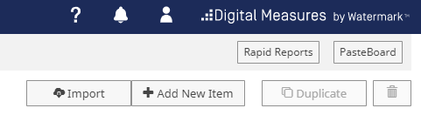
- Complete the Activity Form.
NOTE: You may copy and paste from another document if you wish.
- If applicable, click Add in the Author/Editor area to add multiple authors or participants.
NOTE: The first author is considered the owner and all added authors will have the entry automatically added to his/her Digital Measures activity; however, he/she will be unable to edit the entry.
- Click Save or Save + Add Another to save your activity citation. 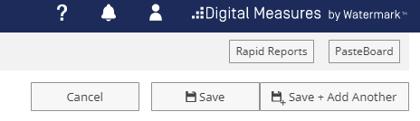

Edit an Activity
- Click on the Activity Category where the activity can be found.
- Click the Activity you wish to edit.
- Click Save to save your activity citation.

Delete an Activity
- Click on the Activity Category where the activity can be found.
- Check the box next to the activity you wish to delete.
NOTE: You can delete multiple activities by checking multiple boxes next to the activities you wish to remove.
- Click the delete icon (trash can). 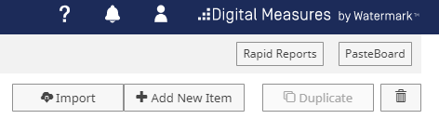
- Click Delete on the confirmation screen to delete the activity or click Cancel if you do not wish to delete.

Duplicate an Activity
- Click on the Activity Category where the activity can be found.
- Check the box next to the activity you wish to duplicate.
- Click the Duplicate button. 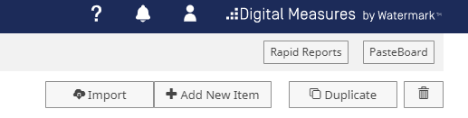
- The duplicating activity will open. You may alter or modify the new item.
- Click Save to add the duplicated item.

Import Activities
NOTE: This function is only available in the Publications Activity Screen.
- Navigate to the Publications Activity Screen by clicking Publications. You will be able to import citations from a variety of sources including EndNote, RefWorks, Zotero, Web of Science, Google Scholar, Mendeley, Scopus, and PubMed.
- Click Import Items.
- Browse your computer for the file you downloaded from your reference manager by clicking Choose File.
- The Faculty Qualifications System will automatically search for duplicate activities already in the system.
NOTE: For each of the potential duplicate records, you must choose to either skip the record or choose to import.
- Click Continue.
- Once you have verified that the activities are correct that you would like to import, click Import Records.

Search Activities
Use the Search All Activities feature when you are not sure where the activity is. Use the search feature for an individual page if you are sure what category the activity belongs to.
Search All Activities
- On the main overview screen (Activities screen) enter your search criteria in the search box.
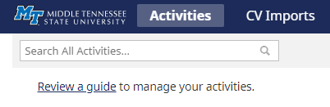
- Click the magnifying glass to begin your search.
Search Individual Pages
- On the main overview screen, click the category in which the activity you are looking for lives.
- Enter your search criteria in the search box.
- Click the magnifying glass to begin your search.

