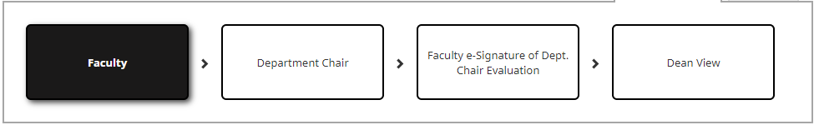
Annual Evaluation Instructions

Faculty Instructions
  - Tenured & Specialized Tracks (Clinical/Coordinators/Instructor/Lecturers)
- Login to Digital Measures.
- Click Workflow.
- From your Inbox, click your current Workflow task.
- There are various components to the Annual Evaluation – Overview of Accomplishments (not required), Electronic OFD (Outline of Faculty Data), and Reassigned Time Request (if applicable). To view the Electronic OFD report that is automatically generated for you:
  - Click the PDF icon next to the Electronic OFD. The Electronic OFD will open, and you will be able to view it. If there are corrections or other items need to be added, close the document and click Save.
  - You will then need to click navigate to the Activities tab and make your corrections/additions.
  - Once you have made your corrections/additions in the Activities tab, return to your Annual Review submission and refresh your report(s).
    - Click Workflow Tasks
    - Click your current Workflow Task
    - Click Refresh Report to re-run the report and reflect your changes.
- Complete all required fields (marked with a red asterisk) and any additional option fields as needed/desired.
- Click Save to save your progress and return later.
- Click Actions and then Submit to submit your report.
NOTE: Submissions are final. Be sure your report is exactly what you intend to submit.

Faculty Instructions
  - Adjunct Faculty
- Login to Digital Measures.
- Click Workflow.
- From your Inbox, click your current Workflow task.
- There are various components to the Annual Evaluation – Overview of Accomplishments, Upload Syllabus for each course taught, and Supplemental Materials (not required).
- Complete all required fields (marked with a red asterisk) and any additional option fields as needed/desired.
- Click Save to save your progress and return later.
- Click Actions and then Submit to submit your report.
NOTE: Submissions are final. Be sure your report is exactly what you intend to submit.

View Submission Status
- Login to Digital Measures.
- Click Workflow.
NOTE: You will see your submission in your History section. Check the Current Step column to see where your Workflow submission is in the overall process.

Faculty Response or e-Signature
- Login to Digital Measures.
- Click Workflow.
- You will see you have a new task with Faculty Response or Faculty e-Signature in the Current Step status column.
- Click the task to begin your acknowledgement.
- View any comments or responses from the Department Chair or the Dean.
- Select the affirming statement in the drop-down box.
- Type your name in the textbox provided to certify that you have received your annual evaluation.
- Click Complete once you have finished.

Department Chair Instructions
- Login to Digital Measures.
- Click Workflow Tasks.
- From your Inbox, click on the faculty member submission you wish to review. You will see the faculty member’s name in the Subject Column in your inbox.
- Click any documents or reports to view them. They will open in a new screen.
- Upload or enter any comments you wish to add in the upload or comment box provided.
Tenured/Specialized Tracks: Upload Evaluation Letter and enter assessment of Reassigned Time Outcomes, if applicable.
Adjunct: Enter comments about Evaluation of Teaching and Summary of Annual Performance.
- Click Submit to move the faculty member’s submission to the next step.

Dean Instructions
- Login to Digital Measures.
- Click Workflow Tasks.
- From your Inbox, click on the faculty member submission you wish to review. You will see the faculty member’s name in the Subject Column in your inbox.
- Click any documents or reports to view them. They will open in a new screen.
- Add any comments you wish to add in the comment box provided.
- Click Actions and then Complete to complete the faculty member’s evaluation workflow.

