Access 25Live at mtsu.edu/25live. Use Chrome or Firefox as your Browser.
Sign In at the top right:
Use Create Event button in the middle of the Dashboard:
or the Event Form button at the top right:
Enter the Event Title. The Title is a required field and should be descriptive: if the event will be advertised, this will be how users will see it.
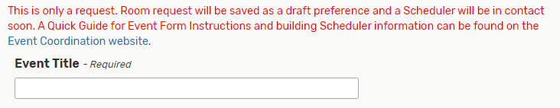
Select an Event Type from the drop-down box (required):
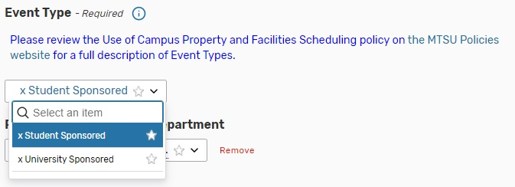
Enter the organization sponsoring the event. Type to search:
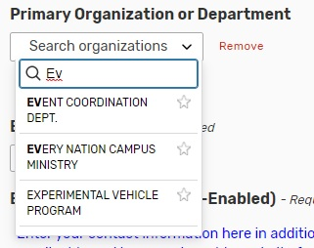
Enter the Event Head Count. Then, type (or paste) in your contact information and a description of the event:
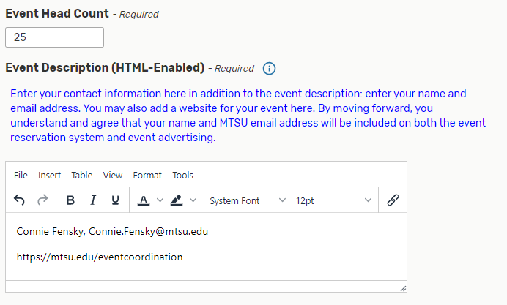
Enter the Event Date. If it is a repeating event, enter the first date.
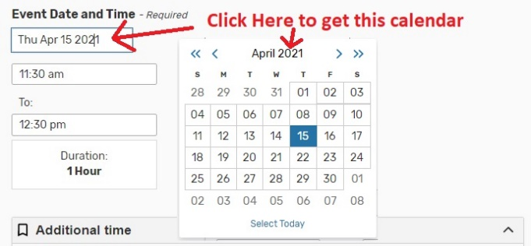
Enter the Event Times. You may either drop down the box or type in with am/pm or military time (the time shown is 10:45pm):
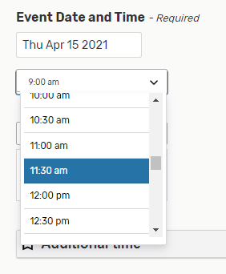
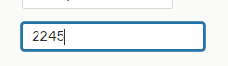

To add Setup/Pre-Event Time, or Takedown/Post-Event Time, expand Additional Time with the arrow. Then type in the extra time your event requires:
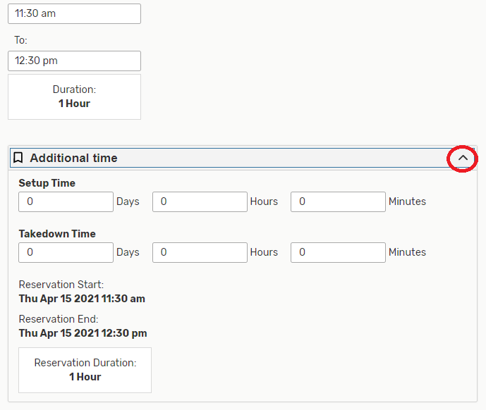
Click on the Repeating Pattern button to enter repeating reservations, or just click on the dates on the calendar:
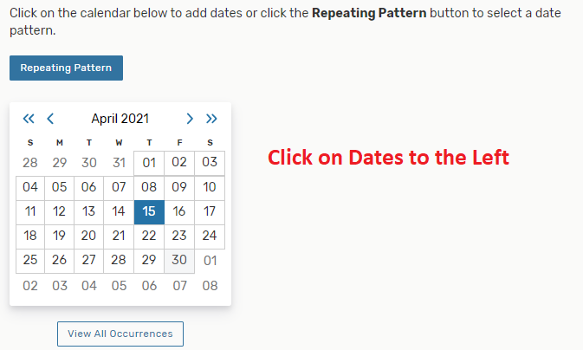
To choose your Location(s), type a location name then press Search:
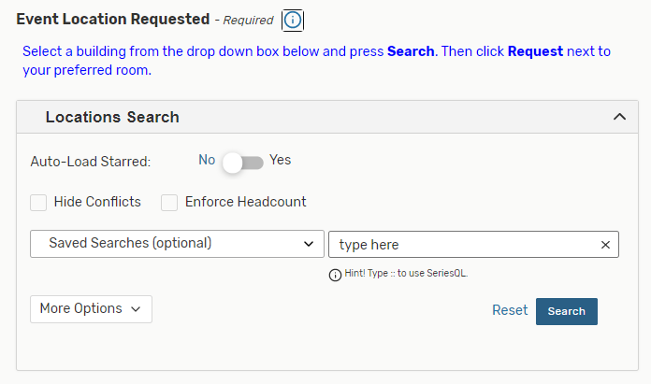
From the list of locations, reserve the one(s) you want by selecting the Request button:
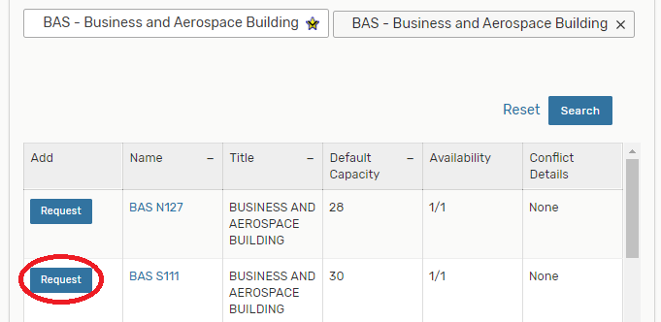
25Live adds the selected location(s) to the page:
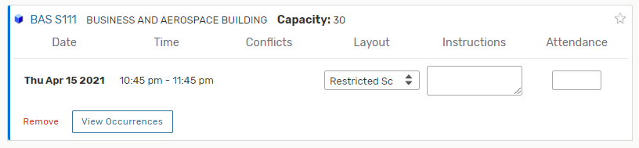
Answer the Custom Attribute questions (you may add those associated with your departmental calendar, if instructed to do so, by clicking the Add a Custom Attribute button).
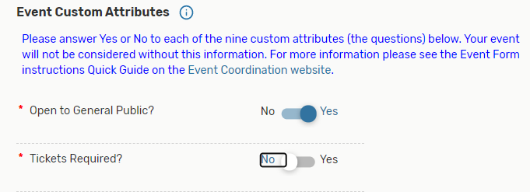
Enter any set-up notes:
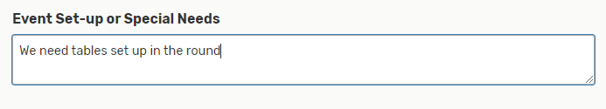
Notice that the title of your event is on a tab at the top of the page, and you can jump to any field with the links at the left-hand side:
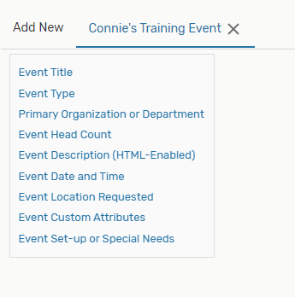

Preview the event information and, once you’ve entered all the event information, click the Save button to save the event request.
Your event request will be saved. You will be shown the Event Detail screen, which looks something like this, with some notifications to the bottom left of your screen letting you know of the success of the saved request:
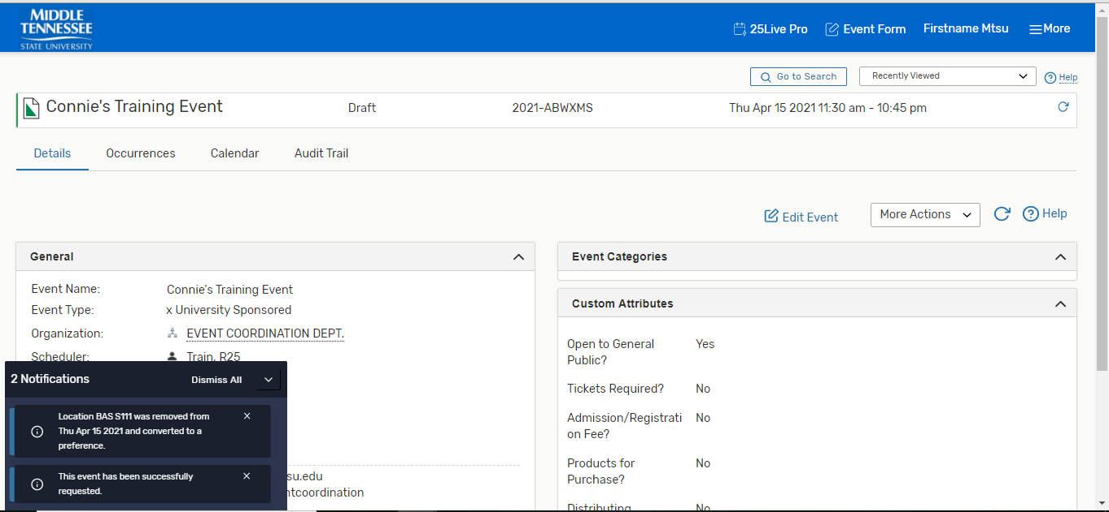
You will receive an email telling you that your request was received, and shortly thereafter, a scheduler will contact you to confirm the reservation. Event advertising should not take place until you receive confirmation from a scheduler.

