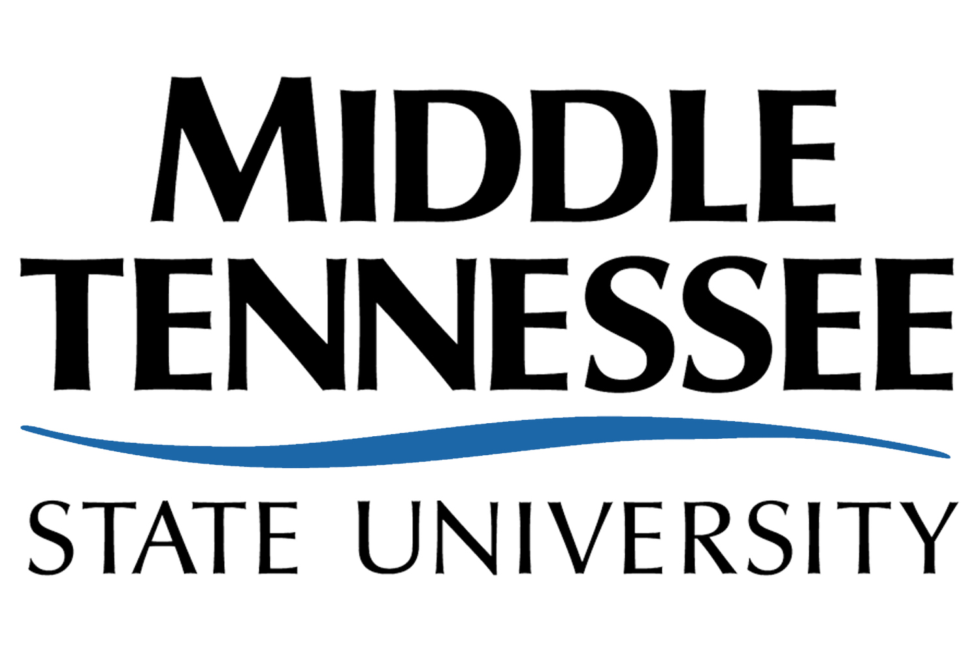

Academic Affairs Liaison Committee

Meeting Minutes

October 12, 2011, 3:00 pm

Cope Conference Room
___________________________________________________________________

Members Present – M. Arndt, C. Beauchamp, S. Boyd, J. Brickey, L. Burriss, N. Callender, L. Clark, C. Cooper, W. Cribb, L. Dubek, G. Freeman, Z. Khan, A. Lutz, K. Mathis, G. Zlotky

Members Absent –

Members Excused – K. Nofsinger

Additional Attendees – B. Bartel

___________________________________________________________________

Action Items
- Dr. Bartel began by discussing the search for the Dean of the Library. Recommendations must be in to Dr. Bartel prior to Fall break. The search for the Dean of CBAS will begin very soon. The timeline for this search will be fairly short. Dr. Bartel met with the Chair’s Council and spoke with them regarding recruitment, retention and graduation. He shared that some Chairs may be apprehensive about the Administration looking at their departmental retention rates. Dr. Bartel thinks it is important to see this data.
- Warner brought up the counseling process through the University College. Dr. Bartel is in favor of the advising by the University College of freshmen who are looking for a program. However, he is more concerned with students persisting from the Junior to the Senior year. He stated that aptitude should be reviewed for incoming students. Scott brought up a problem with nondeclared students (who intend to declare a specific major) trying to enroll in major courses; however, the new advising system is making this difficult. Dr. Bartel offered that a specific committee on campus (Standards and Rules) is tasked with dealing with this issue. Dr. Bartel shared that Customs needs to be adjusted. He is currently going on recruiting visits to see how they are run.
- Michael asked how we identify reasons why students leave. Dr. Bartel said that this happens with unsuccessful students in “exit” interviews. He said that economics is a primary reason for students that leave. He stated that the Arts presents a good model for recruiting in high schools. He stated that departments with recruiting plans may receive funds. Dr. Bartel would like to hold the number of incoming freshmen steady. He would like to see a much more aggressive Masters level recruiting effort. He said that the University has a plan for bringing in international students.
- The Tennessee Pathway program from Community Colleges was discussed with regard to specific MTSU programs. Dr. Bartel shared that these programs must be honored. Dr. Bartel said that we must initiate new pathways for programs which do not have an established pathway. Dr. Bartel stated that scholarship money for transfer students would be desirable. Dr. Bartel shared thoughts about awarding Associates as students progressed through a program.
- Warner shared an idea wherein students could earn a Bachelors in 3 years and move seamlessly into a Masters program. Dr. Bartel said that this is currently being planned.
- Dr. Bartel stated that MTSU is currently in a good position. He also shared that a recent study showed that our students are not receiving critical thinking/problem solving experiences in the senior year.
- Summer offerings being increased to match fall and spring was questioned. Dr. Bartel does not think students would utilize the summer as fully as the fall and spring.
- Dr. Bartel’s thoughts on enrollment standards was requested. He stated the MTSU would desire a system similar to that of U of M. He stated that the admissions standards should go to the Senate for review.
- Warner shared information regarding a “killer” class committee targeting courses for which large numbers of students fail. Warner shared that data garnered through the actions of this and other committees showed that an ACT of 18 and a high school GPA of 3.0 were indicators of success.
- Dr. Bartel shared that the Academic Misconduct Policy issues may be addressed by setting MTSU rules which are more strict than those issued by TBR.
- Larry brought up the idea of students as scholars as opposed to customers. Dr. Bartel shared that this is a national issue. The discussion moved to how well our students are trained as viewed by employers. Employer feedback was discussed as necessary feedback. Dr. Bartel shared that alumni feedback has prompted work in improving a particular college’s program. Dr. Bartel shared that liberal arts education is very important.
- Math across the curriculum in conjunction with writing across the curriculum was suggested. Industry must share issues like this with the TBR to bring attention to them.
- The request for course syllabi which allegedly relates to Islam was discussed. MTSU is the only school for which this information was requested. Dr. Bartel stated that these courses are benign.
- Noninstructional assignments were questioned. Dr. Bartel said that a committee is being formed and will consist of three Senators to deal with this issue.

Respectfully submitted,

Nate Callender
2011-2012 Faculty Senate Recording Secretary

Edited:

