O. Tom Johns’ Scholarship

2013
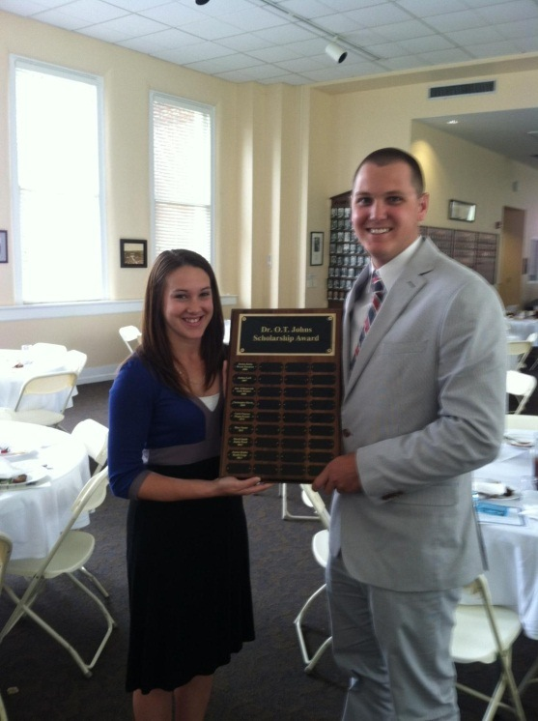
Jessica Hobbs J. Heath Forge

2012
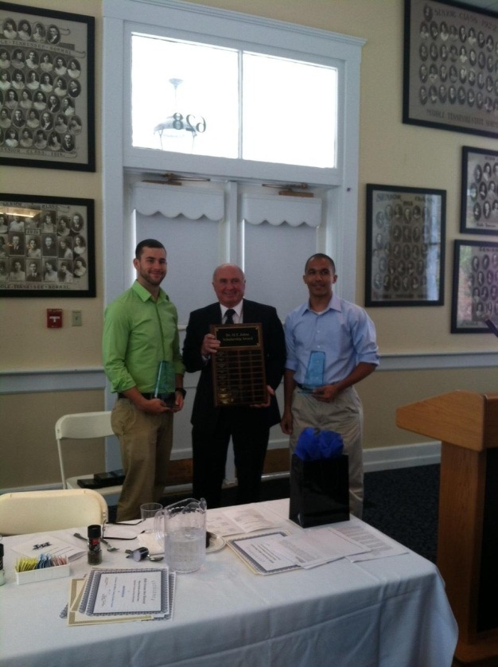
David Smith Justin Wood

2011
Mary Vassar
2010
Carrie Pearson
Megan Koontz
2009
Christopher Harris
2008
Alan Killingsworth
Andy Braden
2007
Joshua Leek
2006
Jessica Kirby
Bryan Sizemore

