THE TITLE OF THE THESIS IS CENTERED 12 POINT FONT ALL CAPITAL LETTERS BOLD FACE

By
Your Name

APPROVED:
Graduate Committee:
_______________________________________________________
Supervisor Dr. professor’s name (Computer Science)
_______________________________________________________
Dr. professor’s name (Computer Science)
_______________________________________________________
Dr. professor’s name (Computer Science or other department)

________________________________________________________
Dr. chair’s name, Chairperson Computer Science Department

________________________________________________________
Dr. dean’s name, Dean of the College of Graduate Studies
YOUR EXCELLENT THESIS TITLE HERE IN 12 POINT TIMES NEW ROMAN ALL CAPITAL LETTERS

By
Your Name Here

A thesis submitted in partial fulfillment
of the requirements for the degree of

MASTER OF SCIENCE
in
Computer Science

Middle Tennessee State University

Graduation Month Spelled out space year (e.g., May 2012)

ACKNOWLEDGEMENTS
Write your thanks here.

ABSTRACT
The abstract can be no more than 150 words. It goes on this page.
TABLE OF CONTENTS
LIST OF TABLES vii
LIST OF FIGURES viii
LIST OF SYMBOLS AND ABBREVIATIONS ix
Chapter
I. INTRODUCTION 1
II. PAGINATION 2
III. SPACING 3
IV. FIGURES AND TABLES 4
V. REFERENCES AND CITATIONS 7
VI. CHAPTERS, SECTIONS, AND SUBSECTIONS 8
BIBLIOGRAPHY 9
Appendix
A –SOURCE CODE 11
B – TEST SUITE 12
C – IRB APPROVAL 13
D – COPYRIGHT APPROVALS 14

LIST OF TABLES
Table 1 – Professional Computer Science Emphasis core courses as of Spring 2012 5

Table 2 – Professional Computer Science Emphasis required Mathematics courses as of Spring 2012 6

LIST OF FIGURES
Figure 1 – The course prerequisite structure for the undergraduate courses in the MTSU Computer Science Department as of December 2011. 4

Figure 2 – Example of code as a figure 5

LIST OF SYMBOLS AND ABBREVIATIONS

ACM – Association for Computing Machinery
CPU – Central Processing Unit
DBMS – Database Management System
OS – Operating System
PyXM – Python module which implements software transactional memory
STM – Software Transactional Memory
CHAPTER I
INTRODUCTION
This document is a sample template for the body of a thesis done in the Department of Computer Science at Middle Tennessee State University. You are not required to use this template, but it has been approved by the College of Graduate Studies. All text should be in 12 point font. Do not have any widow lines.
CHAPTER II
PAGINATION
Every page should be assigned a number with the exception of the Approval and the Title pages. Page numbers should be in the same position on each page. In the body, the numbers are in Arabic and are 1 inch from the top of the page and 1 inch from the right edge. In the front matter the numbers are in lower case roman numerals and are centered 1 inch above the bottom of the page. The Approval page is the first page, but it is not numbered. The Title page is the second page, but it is considered the first page for numbering purposes although there should not be a page number on it. Therefore, the first numbered page will be the Acknowledgements (or Dedication) page and will be numbered ii.
CHAPTER III
SPACING
All text must be double-spaced. Also, double-space after chapter number and the chapter title. Double-space before, and after, section headings. Triple-space before, and after, tables and figures. Table/figure data/captions, long quotes (4 lines or more), and references should be single-spaced. All long quotes should also be indented. For example, the entire mission statement for the MTSU Department of Computer Science is:
The Computer Science Department produces graduates with strong problem-solving, communication and team skills who are able to design, implement and document computer software systems. To this end the Department offers Bachelor of Science and Master of Science degree programs. The Departmental faculty is committed to excellence in teaching and actively engages in research and public service activities to support the educational mission of the University and to contribute to the knowledge of the computer science discipline. The Department also provides computer literacy education for the general University population.
Quotes of less than four lines would be quoted within the text. For example, "The Computer Science Department produces graduates with strong problem-solving, communication and team skills who are able to design, implement and document computer software systems."
CHAPTER IV
FIGURES AND TABLES
In this section, we review the basics for figures and tables. Both figures and tables should occur in the text as close as possible to where they are referenced (see Figure 1). They should be numbered consecutively from the beginning of the thesis. If you are putting code in a figure, then use a mono-spaced font such as courier and make sure the figure fits on one page (see Figure 2). Figure captions should be centered beneath the figure.
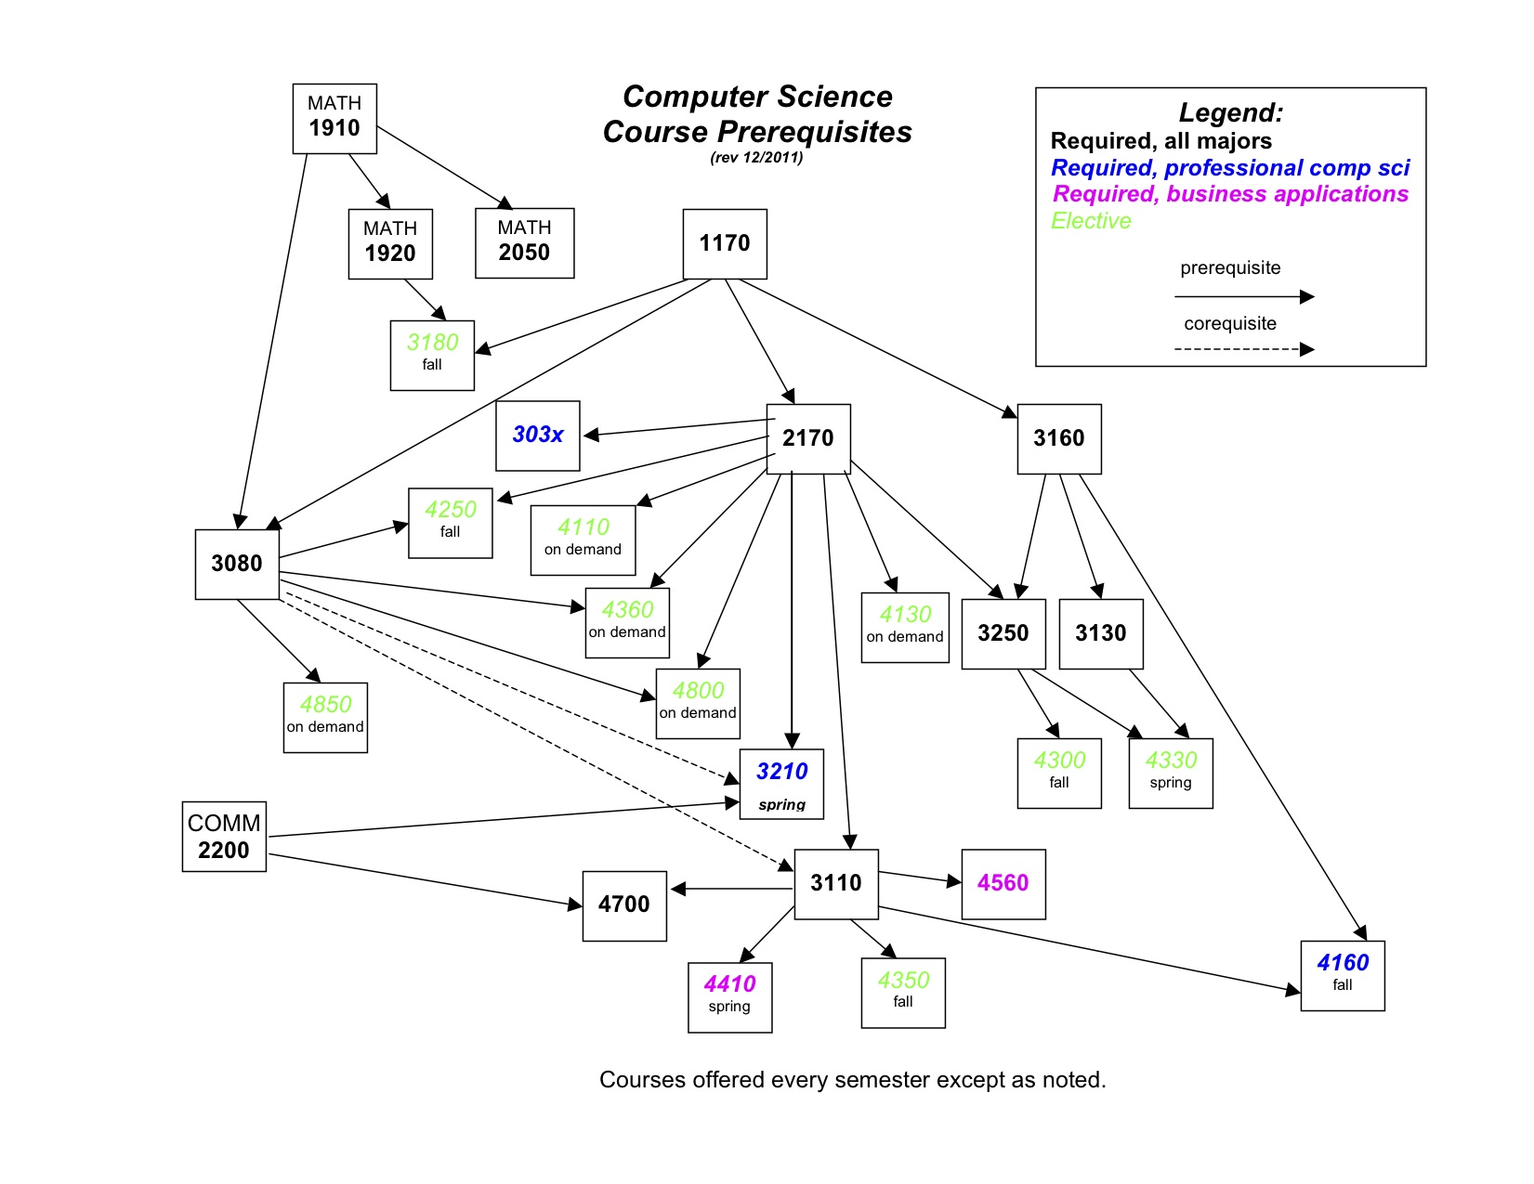
Figure 1. The course prerequisite structure for the undergraduate courses in the MTSU Computer Science Department as of December 2011

#include <iostream>
using namespace std;

int main()
{
cout << “Hello World!”;

return 0;
}

Figure 2. Example of code as a figure

Table 1 gives an example of how captions should be centered above the table. Triple space between figures/tables and before or after any tables or figures that are inserted in the text. For example, this text appears between figure 2 and table 1. Table and figure captions should be single-spaced, and center short captions.

Table 1. Professional Computer Science Emphasis core courses as of Spring 2012

Course | Credit Hours
CSCI 1170 | 4
CSCI 2170 | 4
CSCI 3080 | 3
CSCI 3110 | 3
CSCI 3130 | 4
CSCI 3160 | 3
CSCI 3210 | 3
CSCI 3250 | 3
CSCI 4160 | 3
CSCI 4700 | 3

Table 2. Professional Computer Science Emphasis required Mathematics courses as of Spring 2012
Course | Credit Hours
MATH 1910 | 4
MATH 1920 | 4
MATH 2050 | 3

CHAPTER V
REFERENCES AND CITATIONS
References and citations are done using the accepted ACM reference and citation style. This style is in accordance with both the ACM [11] and the IEEE [10] formats for journal and paper submissions.
References are a numbered list, called the bibliography, ordered alphabetically and formatted according to the ACM reference format. See sample references in the bibliography section of this document. Word may try to underline links, but the correct style is NO underlining. The Bibliography section should come immediately after the last chapter and before the appendices. It is not a chapter, so simply center the word bibliography in bold face, all capital letters at the top of the page.
A citation is given by enclosing the number of the reference in square brackets (as shown above). Note that private communications should be acknowledged in a citation (e.g., [Pettey, private communication]), but they should not be referenced.
CHAPTER VI
CHAPTERS, SECTIONS, AND SUBSECTIONS
Chapter numbers should be in upper case roman numerals. The chapter number and chapter title should be on separate lines, should be in all upper case, should be bold face, and should be centered. All section headings should be on separate lines.
Primary Section Headings
Primary section headings should be centered on a line, bold face and underlined. They should not be all capital letters. Capitalize the first letter the first and last word of the heading, and capitalize the first letter of each of the other words except for articles and coordinating conjunctions and forms of to be.
This is a Secondary Section Heading
Secondary section headings follow the same rules as primary section headings with the exception that they are not underlined.
Tertiary Section Headings
If you need a tertiary section heading, then follow the rules for primary section headings except they should be in italics and do not underline.
Quaternary Section Headings
Quaternary section headings follow the rules of primary section headings except they are in plain text. Anything beyond quaternary headings should be approved by the graduate office.
BIBLIOGRAPHY
- Bowman, M., Debray, S. K., and Peterson, L. L. 1993. Reasoning about naming systems. ACM Trans. Program. Lang. Syst. 15, 5 (Nov. 1993), 795-825. DOI= http://doi.acm.org/10.1145/161468.16147.
- Brown, L. D., Hua, H., and Gao, C. 2003. A widget framework for augmented interaction in SCAPE. In Proceedings of the 16th Annual ACM Symposium on User Interface Software and Technology (Vancouver, Canada, November 02 - 05, 2003). UIST '03. ACM, New York, NY, 1-10. DOI= http://doi.acm.org/10.1145/964696.964697.
- Ding, W. and Marchionini, G. 1997. A Study on Video Browsing Strategies. Technical Report. University of Maryland at College Park.
- Forman, G. 2003. An extensive empirical study of feature selection metrics for text classification. J. Mach. Learn. Res. 3 (Mar. 2003), 1289-1305.
- Fröhlich, B. and Plate, J. 2000. The cubic mouse: a new device for three-dimensional input. In Proceedings of the SIGCHI Conference on Human Factors in Computing Systems (The Hague, The Netherlands, April 01 - 06, 2000). CHI '00. ACM, New York, NY, 526-531. DOI= http://doi.acm.org/10.1145/332040.332491.
- Sannella, M. J. 1994. Constraint Satisfaction and Debugging for Interactive User Interfaces. Doctoral Thesis. UMI Order Number: UMI Order No. GAX95-09398., University of Washington.
- Spector, A. Z. 1989. Achieving application requirements. In Distributed Systems, S. Mullender, Ed. ACM Press Frontier Series. ACM, New York, NY, 19-33. DOI= http://doi.acm.org/10.1145/90417.90738.
- Tavel, P. 2007. Modeling and Simulation Design. AK Peters Ltd., Natick, MA.
- Template for all Transactions (except IEEE Transactions on Magnetics, IEEE Magnetics Letters and IEEE Photonics Journal) DOI=http://www.ieee.org/documents/TRANS-JOUR.doc
- Word template for all ACM SIG proceedings DOI=http://www.acm.org/sigs/publications/pubform.doc
- Yu, Y. T. and Lau, M. F. 2006. A comparison of MC/DC, MUMCUT and several other coverage criteria for logical decisions. J. Syst. Softw. 79, 5 (May. 2006), 577-590. DOI= http://dx.doi.org/10.1016/j.jss.2005.05.030.

APPENDICES

APPENDIX A
SOURCE CODE
It is common, although not required, in Computer Science to include source code that is developed by you for the thesis project. This code should be placed in an appendix.
APPENDIX B
TEST SUITE
Another type of appendix entry would be the suite of test problems used to validate your implementation.

APPENDIX C
IRB APPROVAL FORM
Obtain IRB Approval if you used human or animal subjects.
APPENDIX D
COPYRIGHT APPROVALS
Have copyright permission letters if you used any copyrighted material.

